**Quantitative Metric Formula**

1.1 POS（part of speech）Ratios (Stanford CoreNLP) - POSR

1.1.1 名词比例 - Noun Ratio - NR

1.1.2 动词比例 - Verb Ratio - VR

1.1.3 形容词比例 - Adjective Ratio - AR

1.1.4 副词比例 - Adverb Ratio - AdvR

1.1.5 Other POS ratios can be added with corresponding abbreviations as needed.

（NN NNS NNP NNPS PRP PRP$ WP WP$ VB VBD VBG VBN VBP VBZ MD JJ JJR JJS RB RBR RBS WRB DT PDT WDT CD IN CC UH EX FW LS SYM POS TO RP）

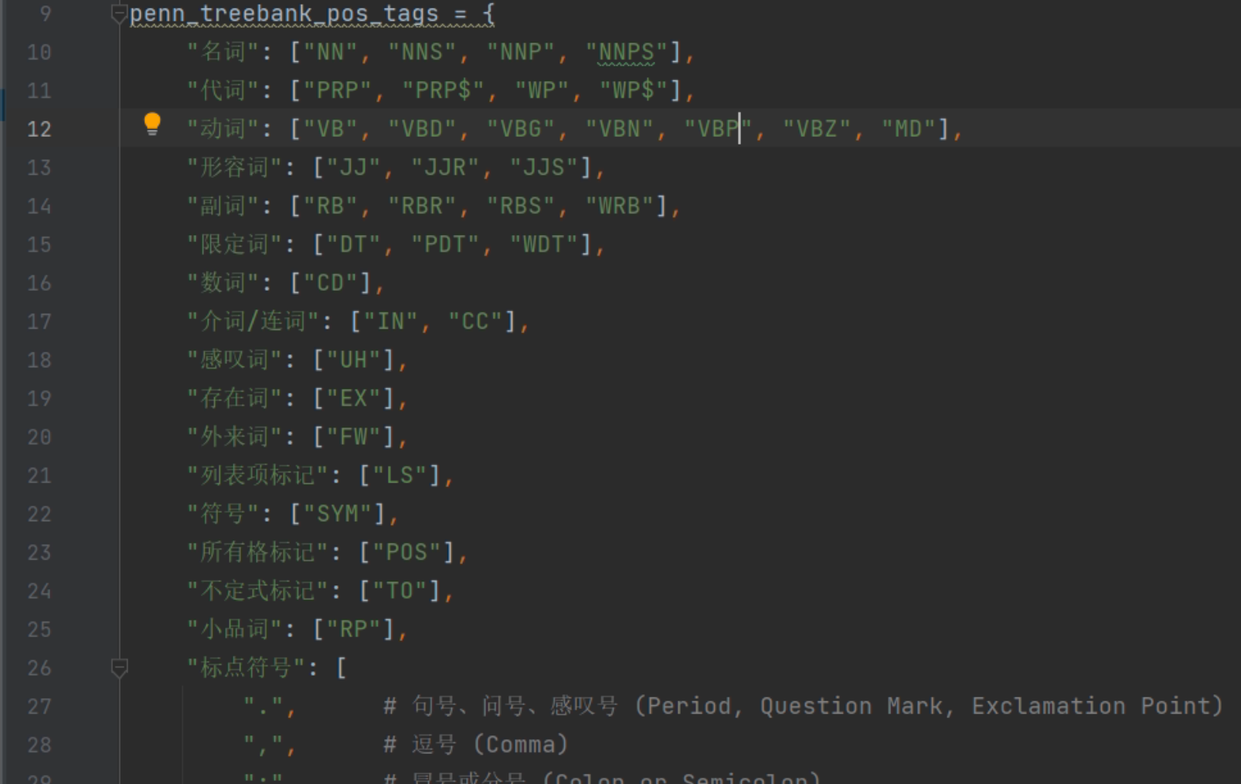

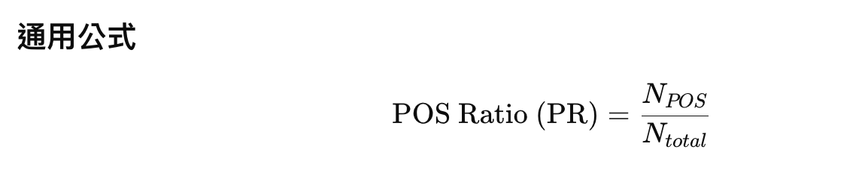

N total means the number of the total words in text.

1.2 实词比例-Content Word Proportion - CWP

content words = noun + verb + adj + adv + pronoun

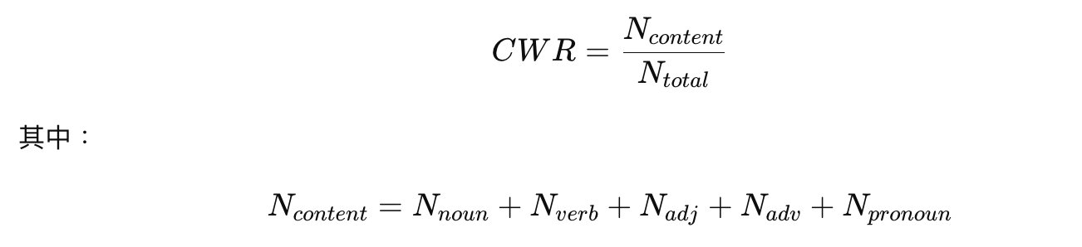

1.3 虚词比例-Function Word Proportion - FWP

虚词亦称function words，包括["限定词", "介词/连词", "感叹词", "存在词", "外来词", "列表项标记", "符号", "所有格标记", "不定式标记", "小品词"]

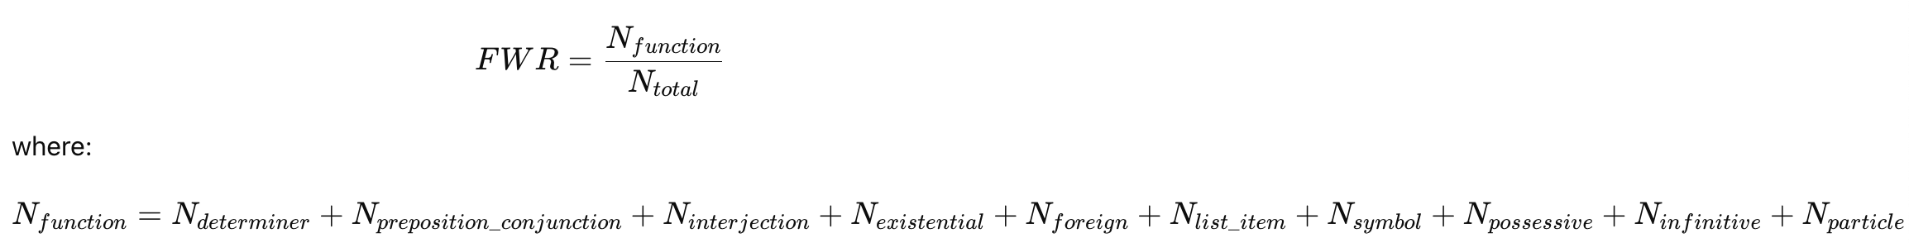

1.4 词长分布 -Word Length Distribution

The word length is calculated by the number of letters in each word.

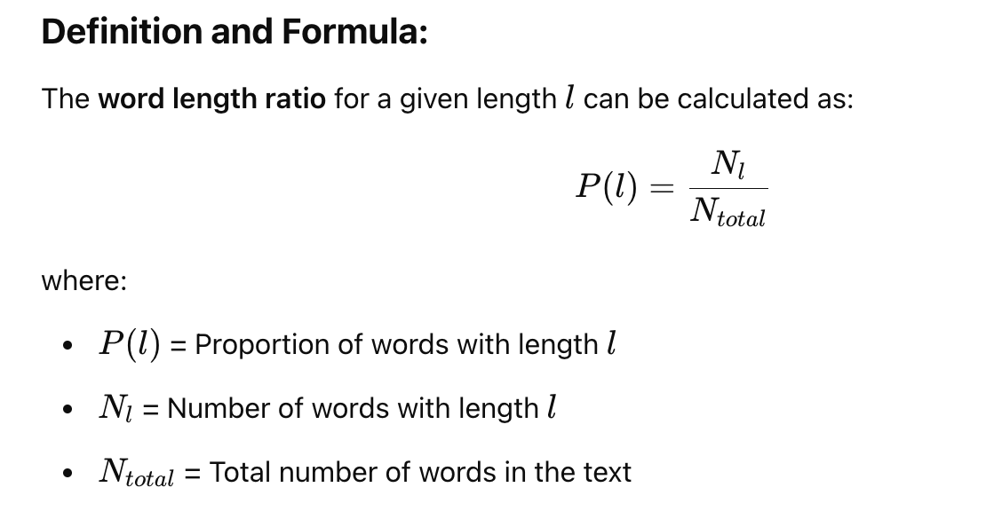

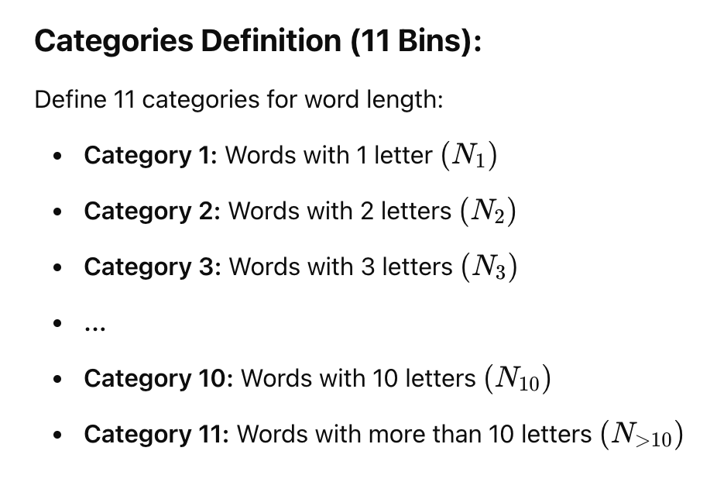

1.5 陈述句，感叹句，疑问句比例Sentence Type Ratio - STR

1.5.1陈述句比例 - Declarative Sentence Ratio - DSR

1.5.2感叹句比例 - Exclamatory Sentence Ratio - ESR

1.5.3疑问句比例 - Interrogative Sentence Ratio - ISR

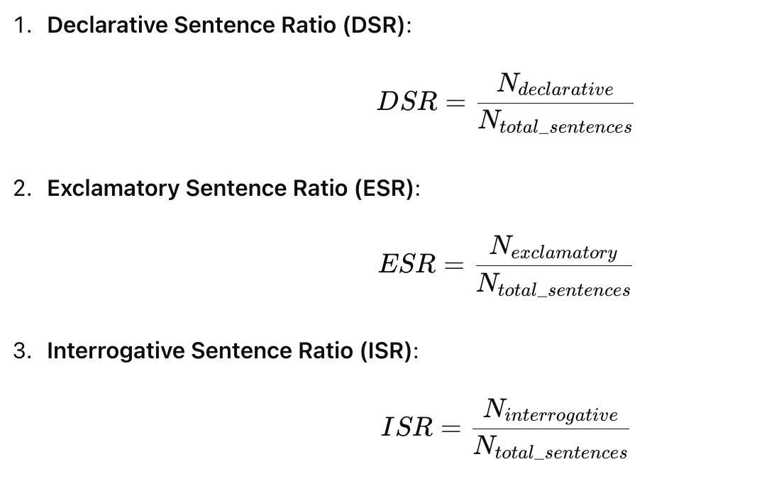

2.1词汇丰富度指标 lexical richness

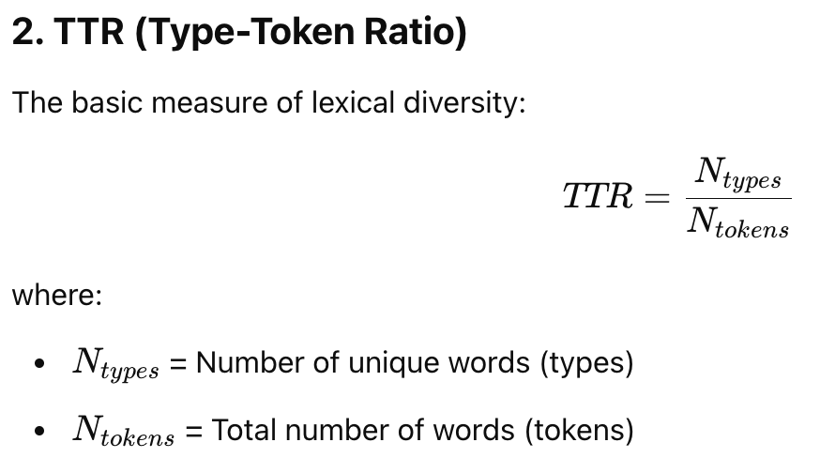

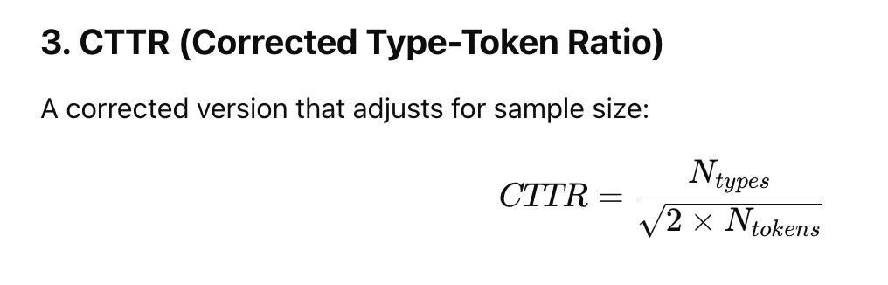

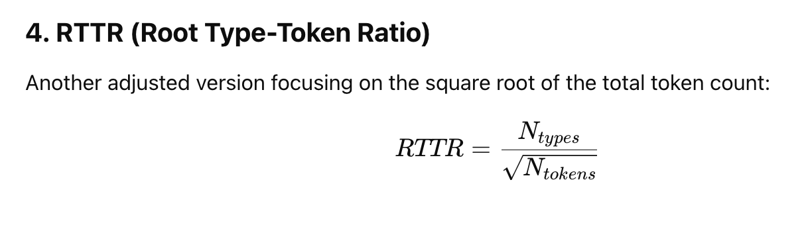

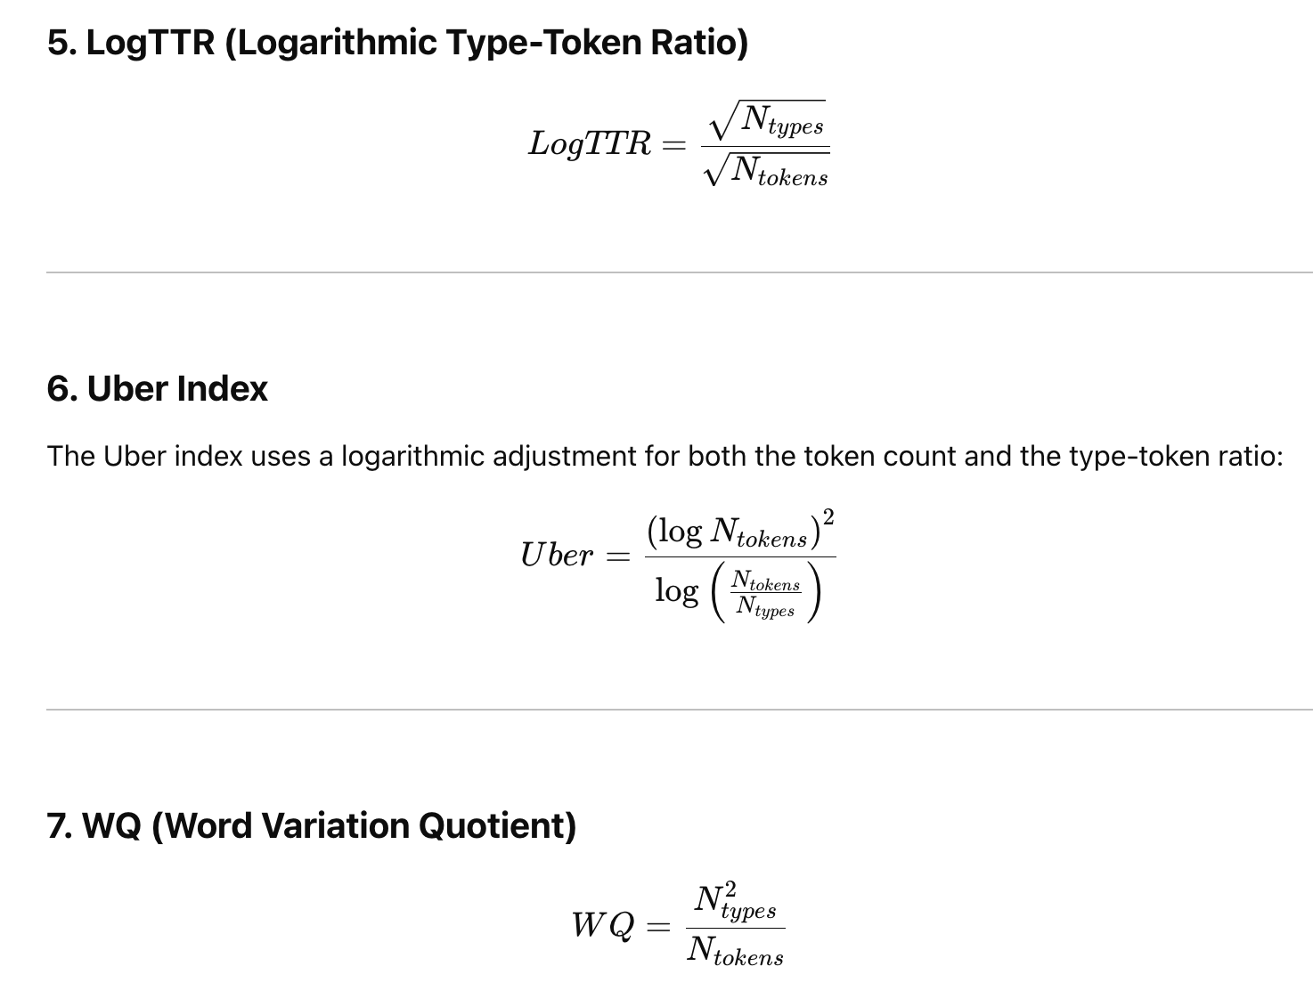

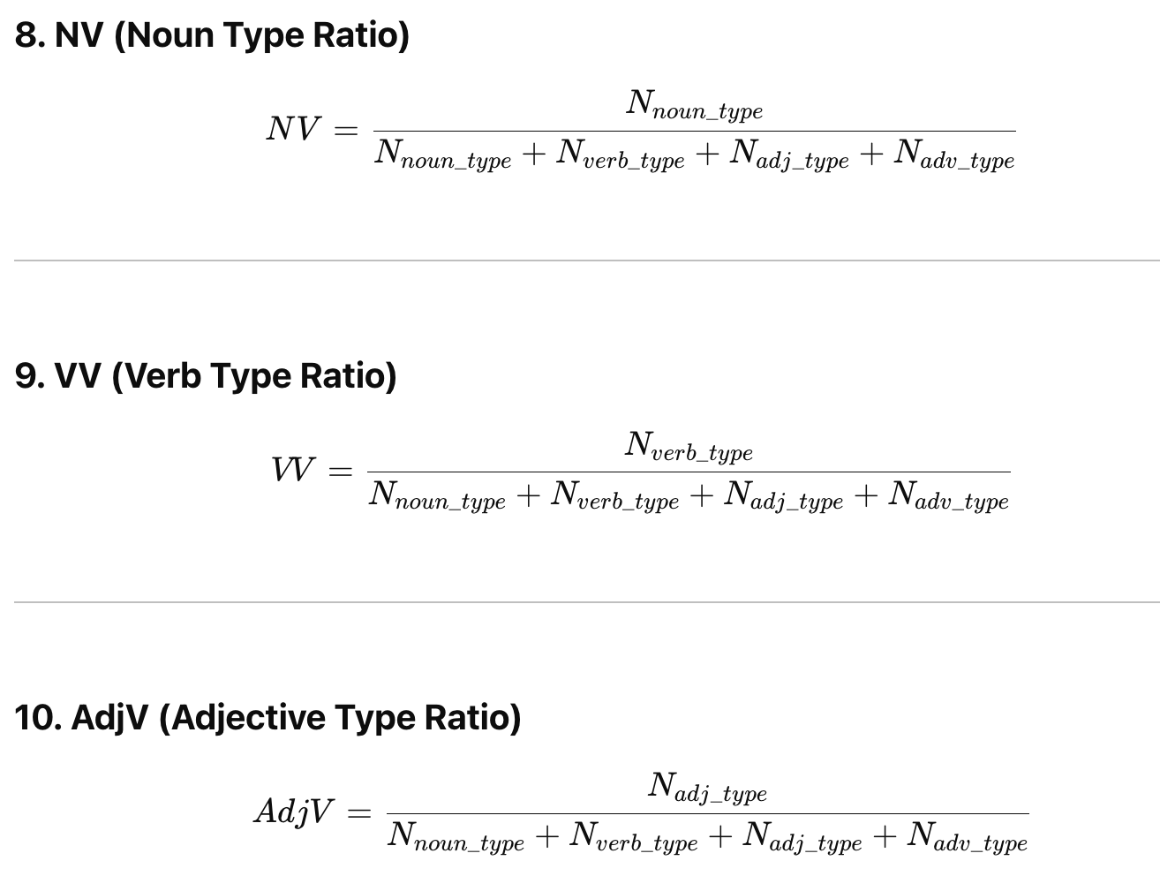

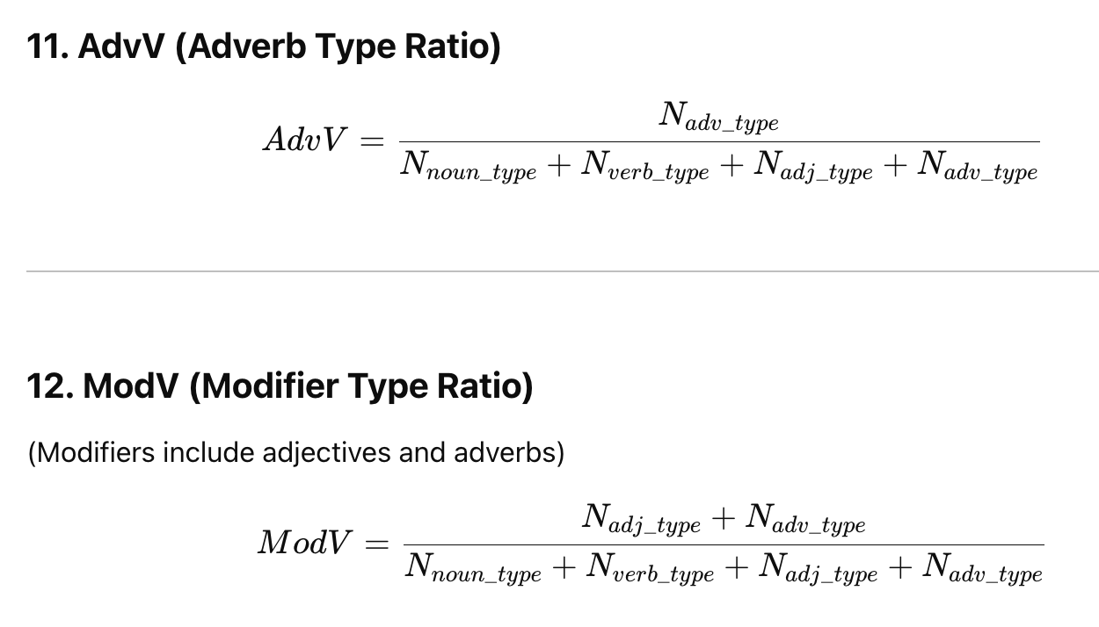

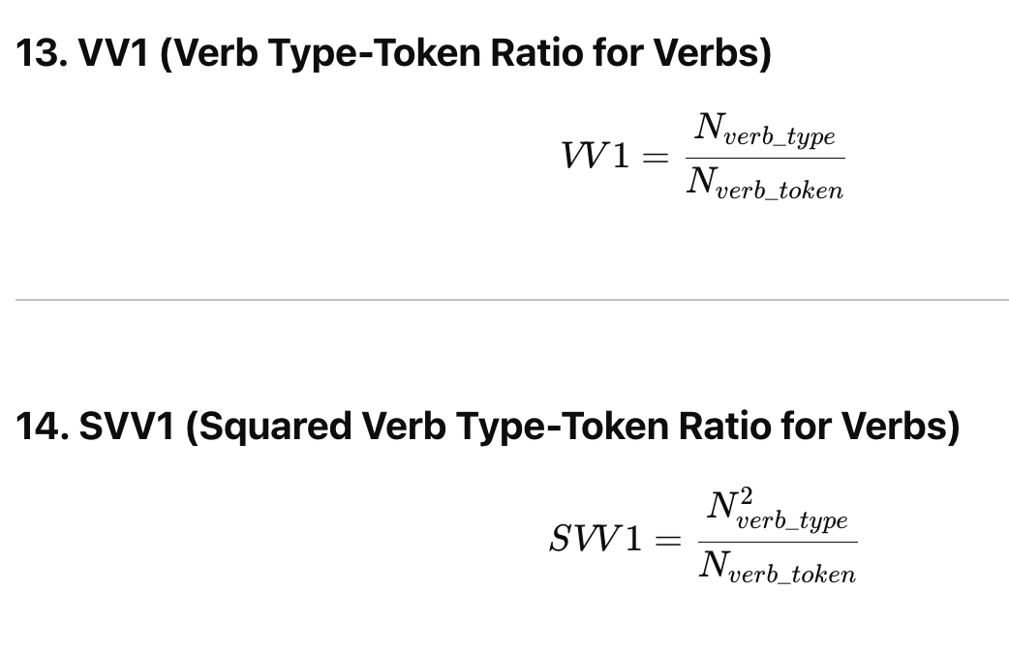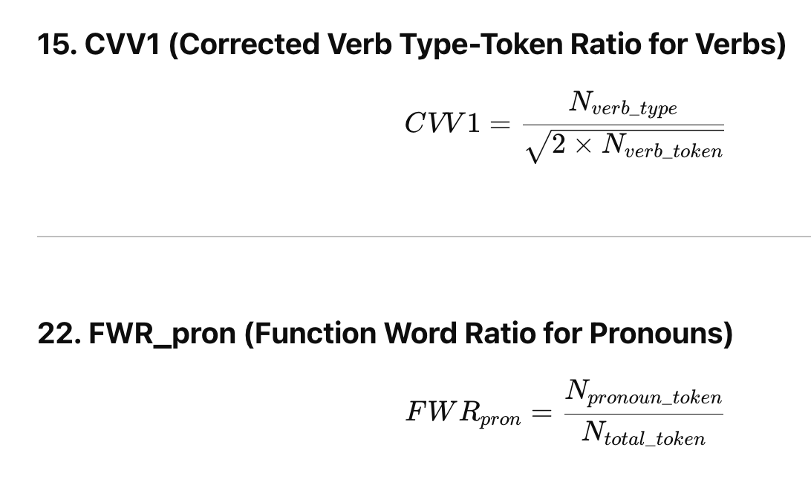

2.2 活动度/描写度/名词性-Activity, descriptivity, nominality

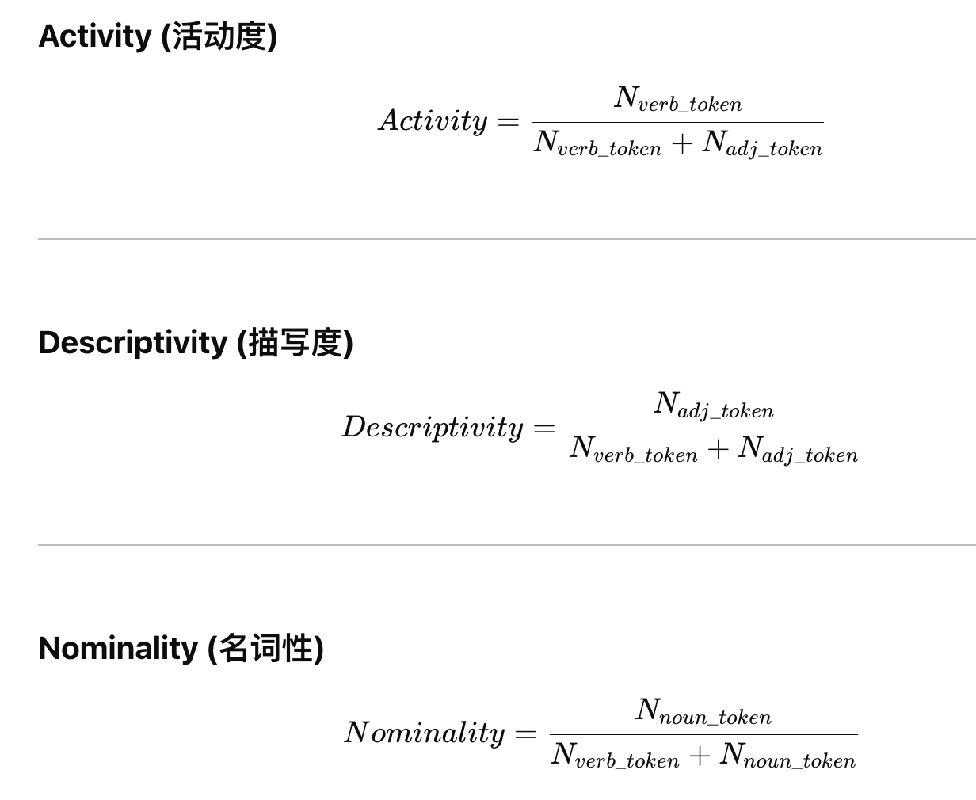

## h-point

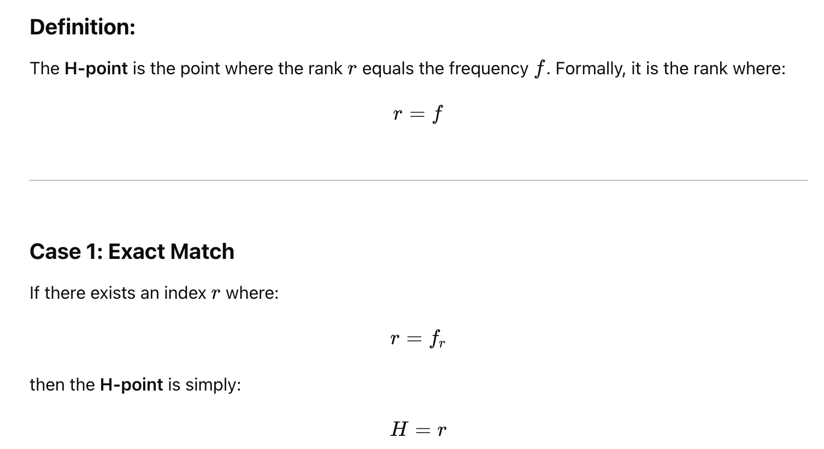

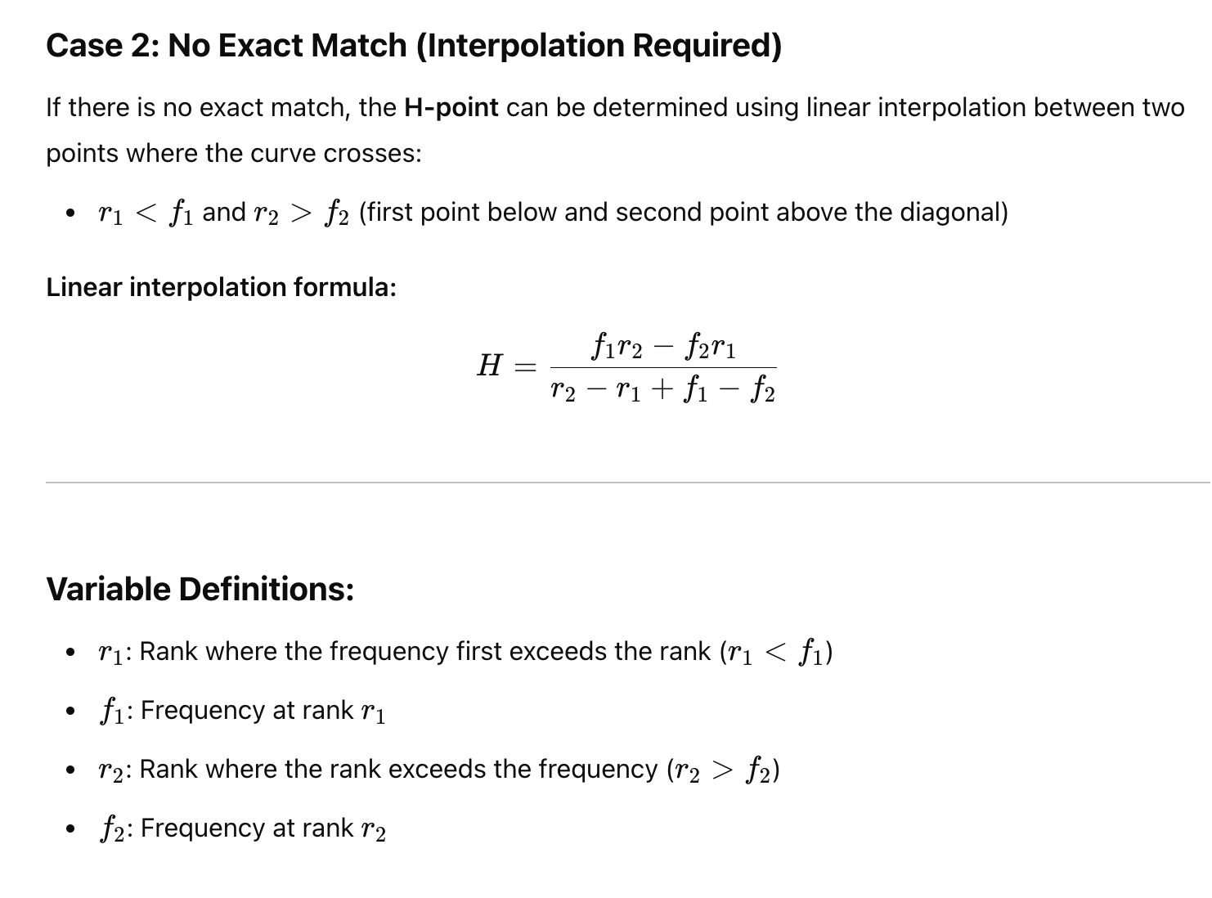

总结如下：

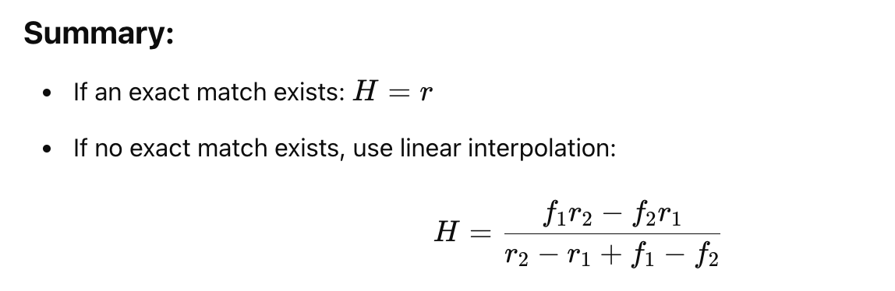

## R1 lexical Richness

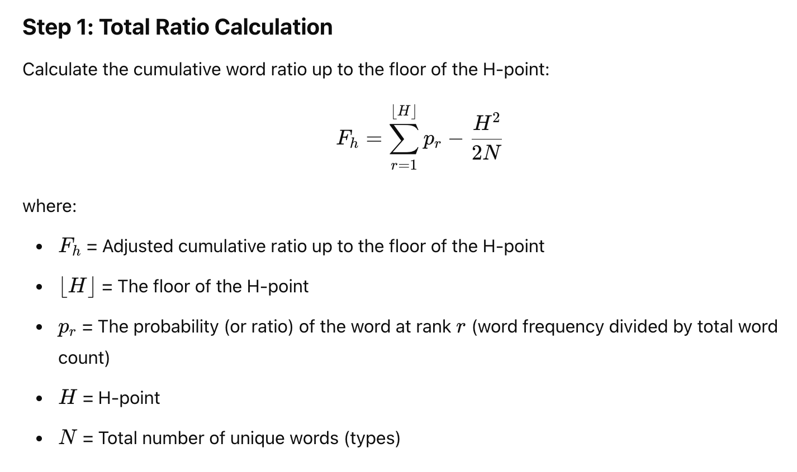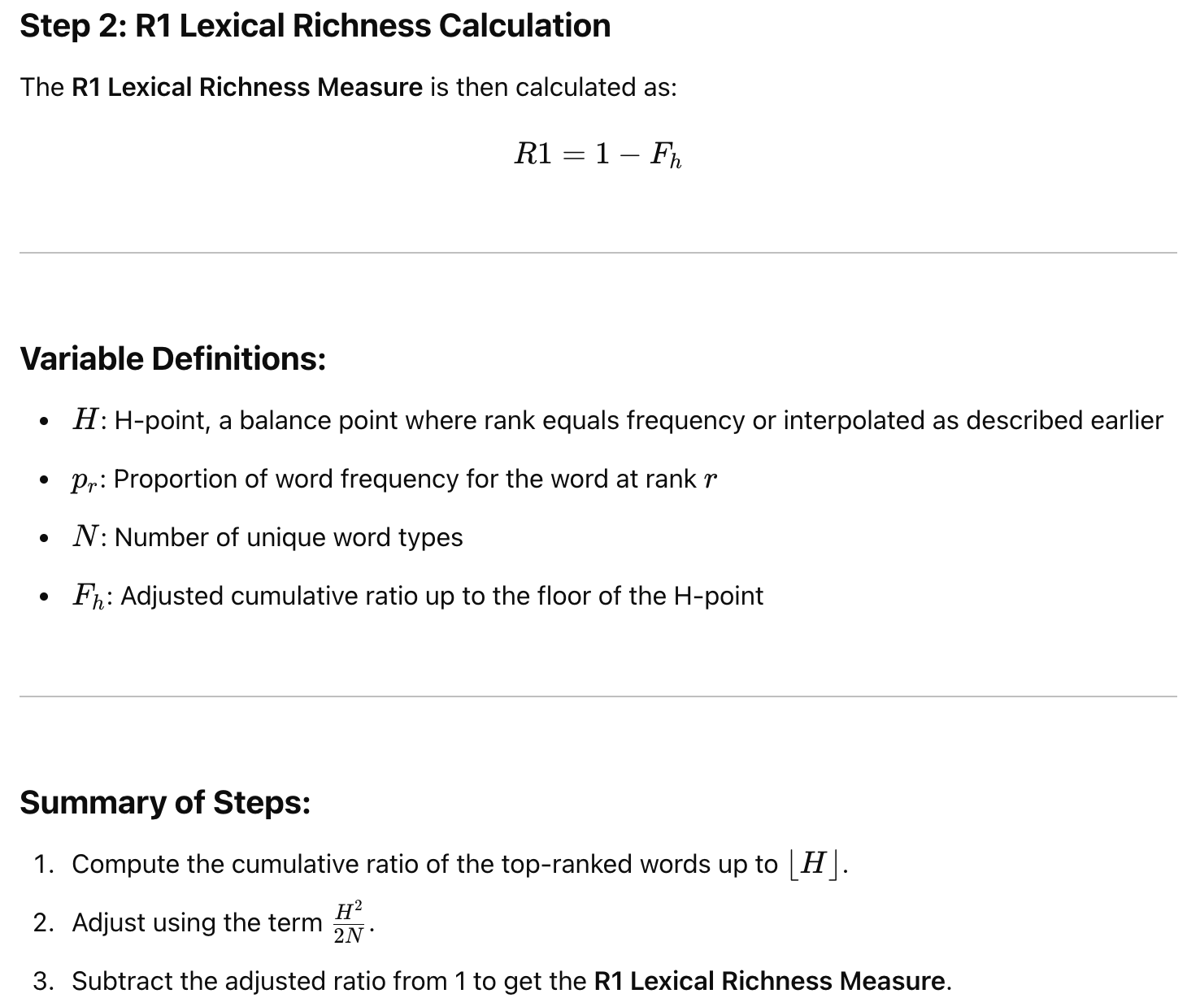

## Text lambda

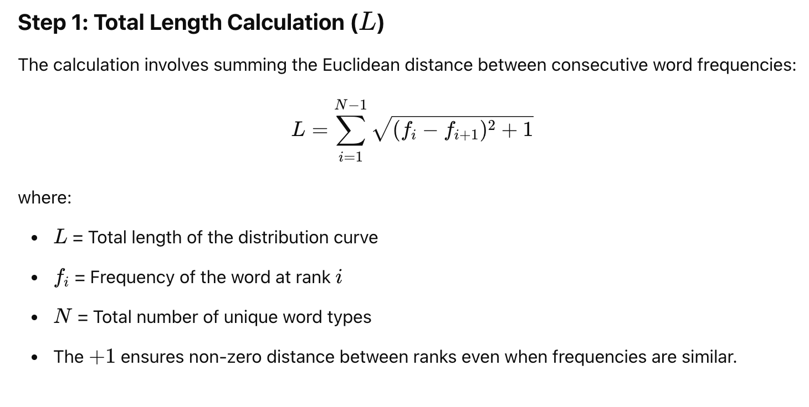

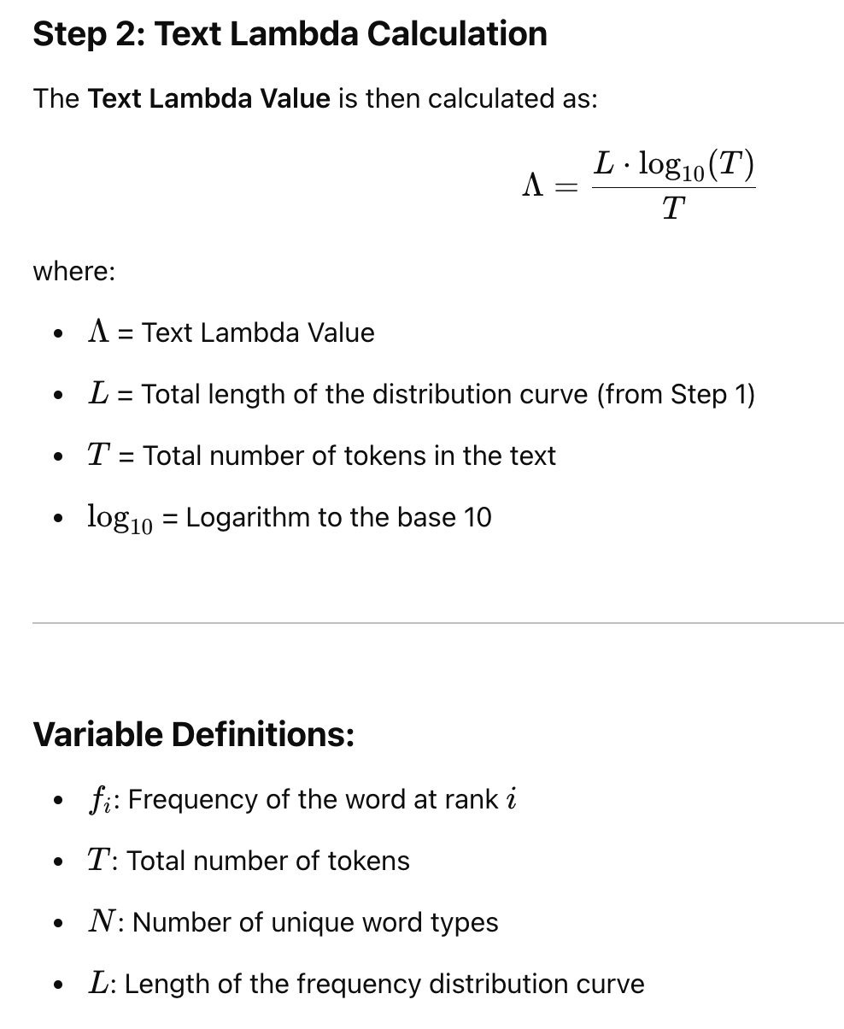

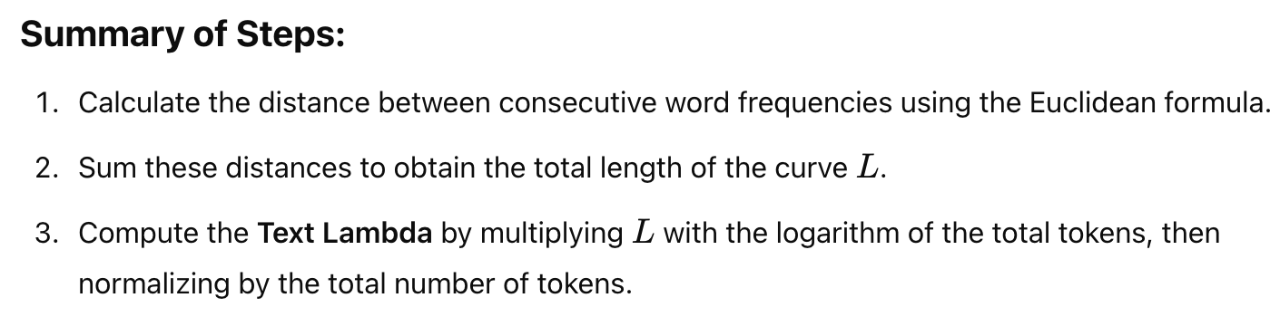

## Author View

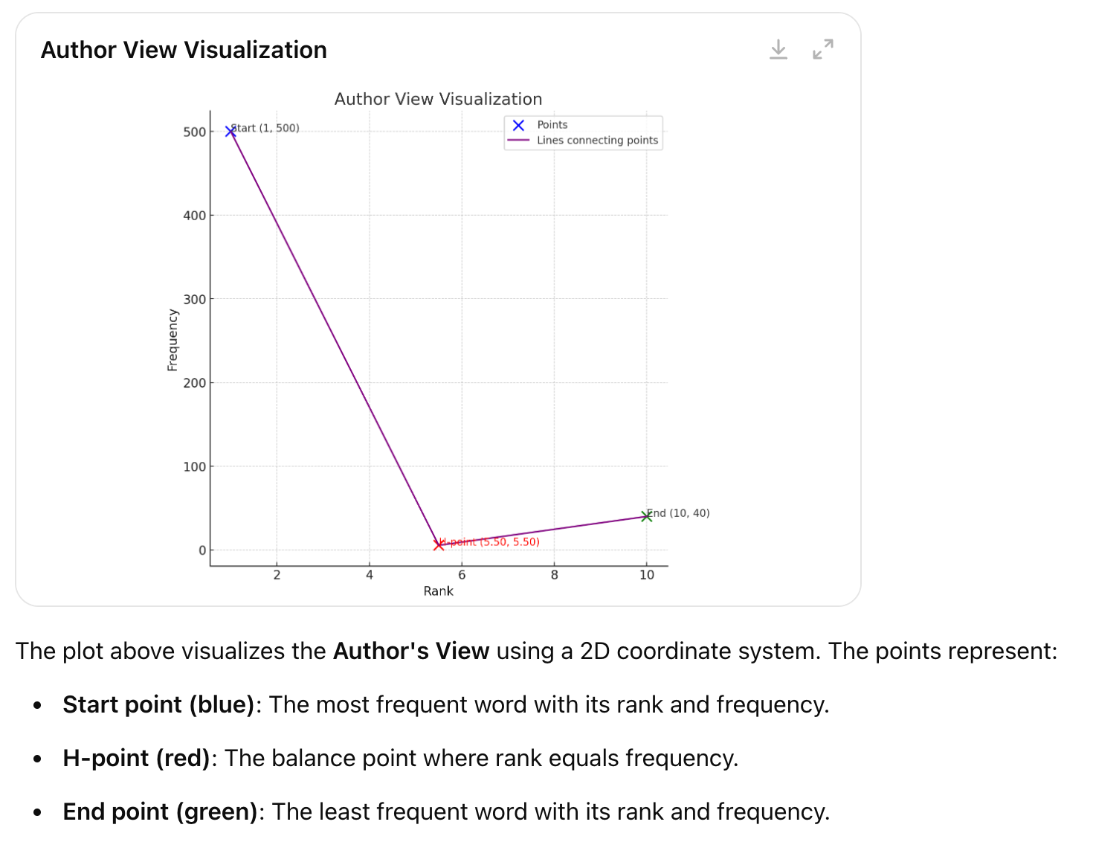

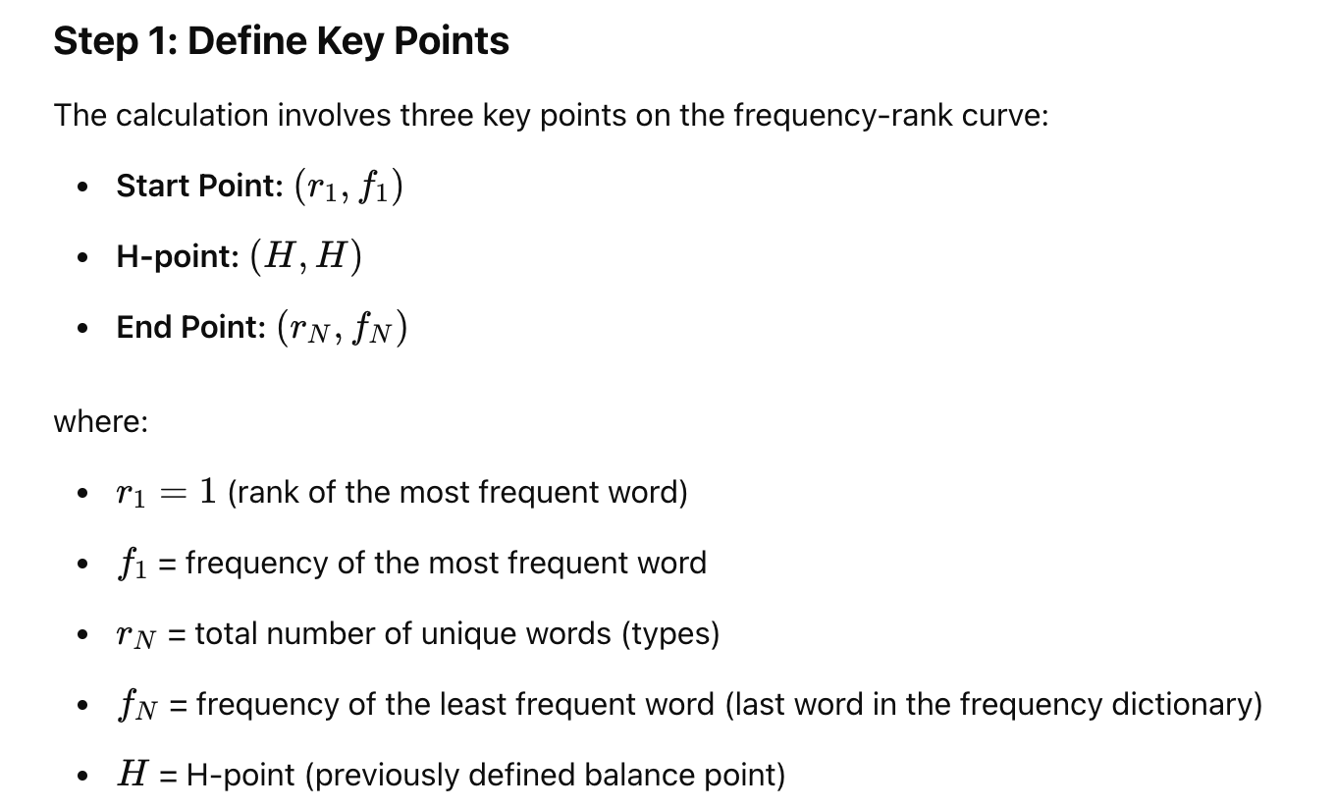

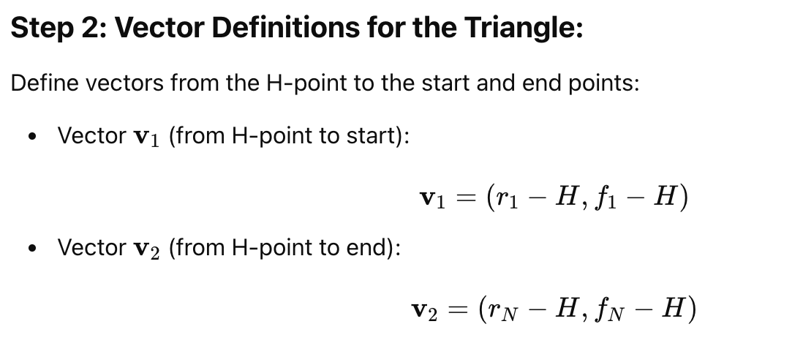

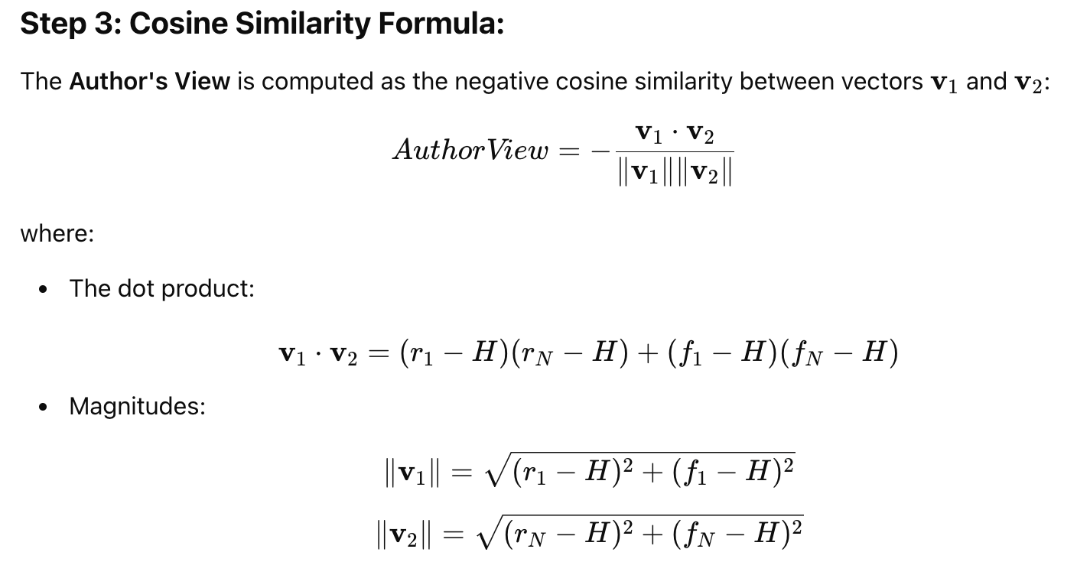

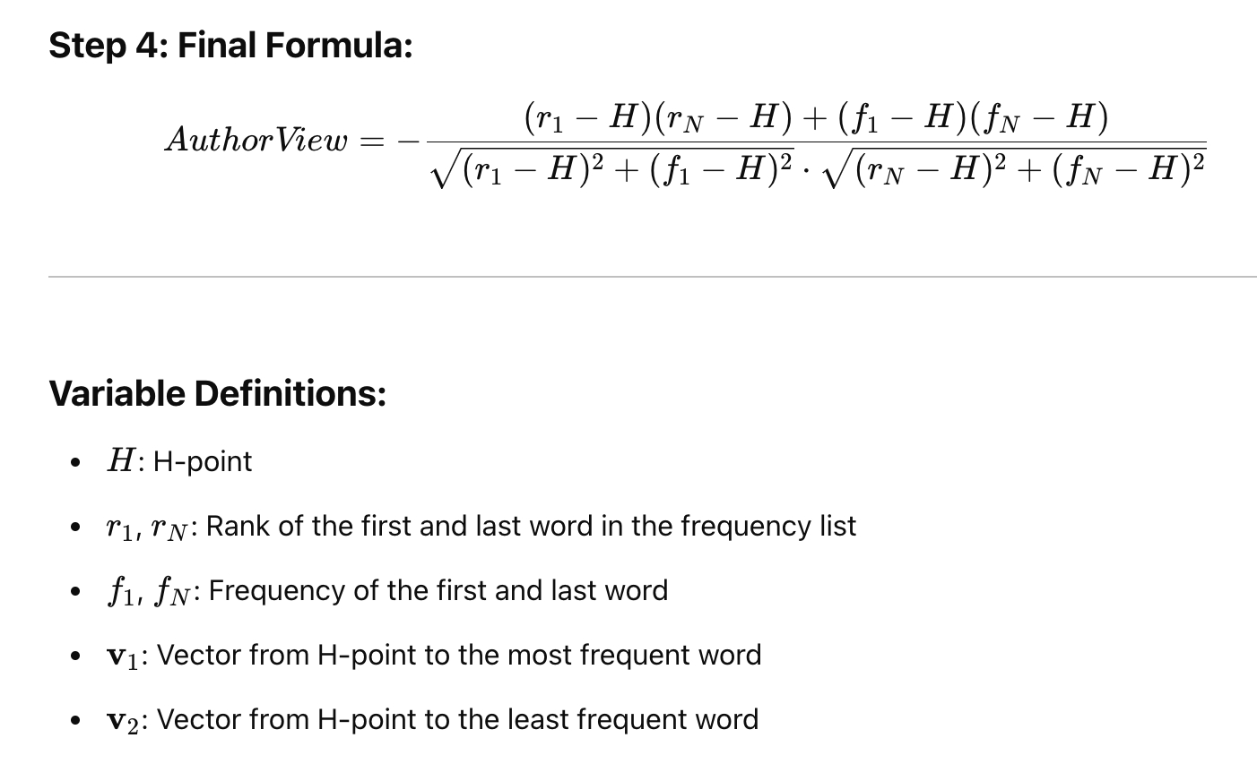

## Verb Spacing

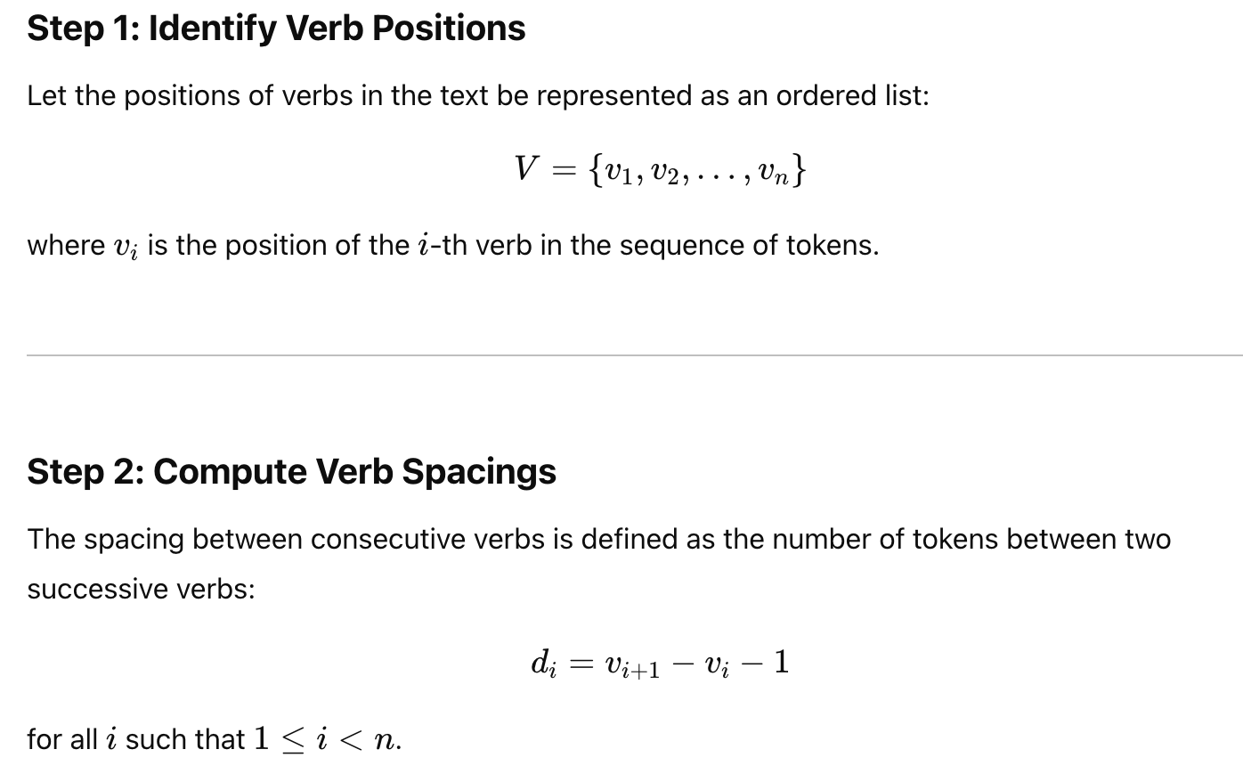

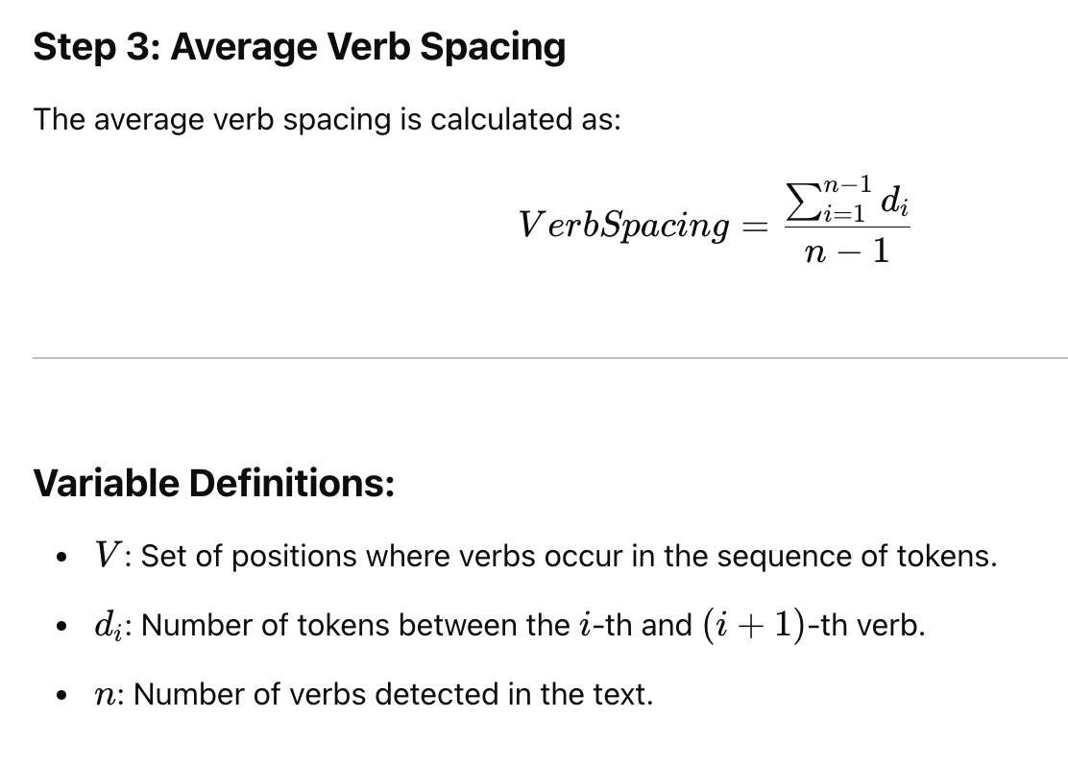

## Text alpha based on h-point

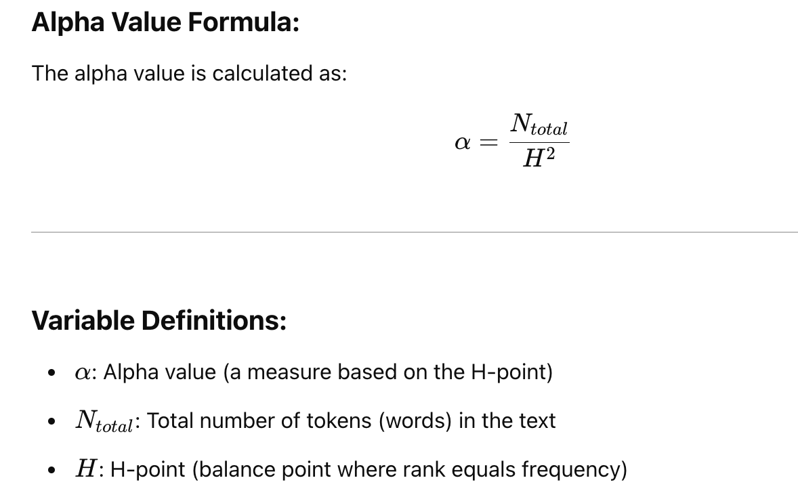

## Lexical Entropy

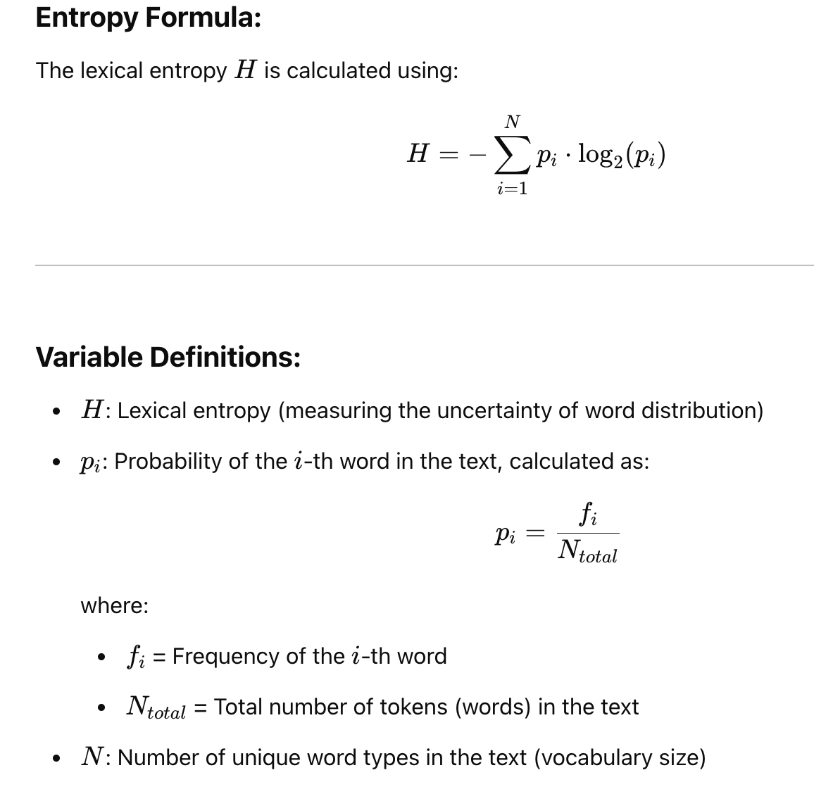

## Relative Repetition Rate (RRmc)

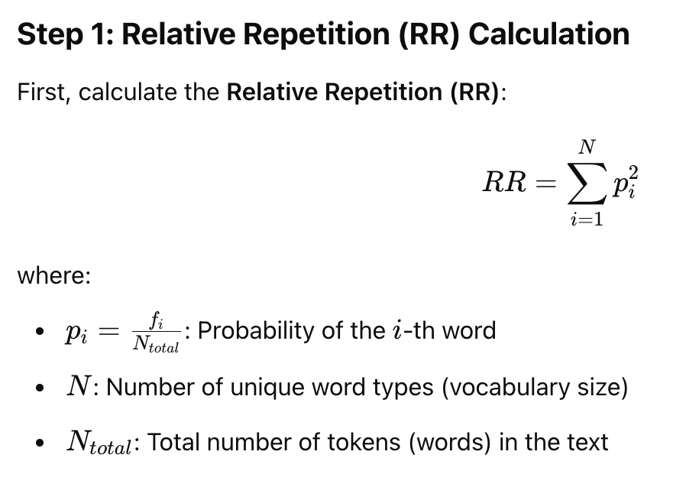

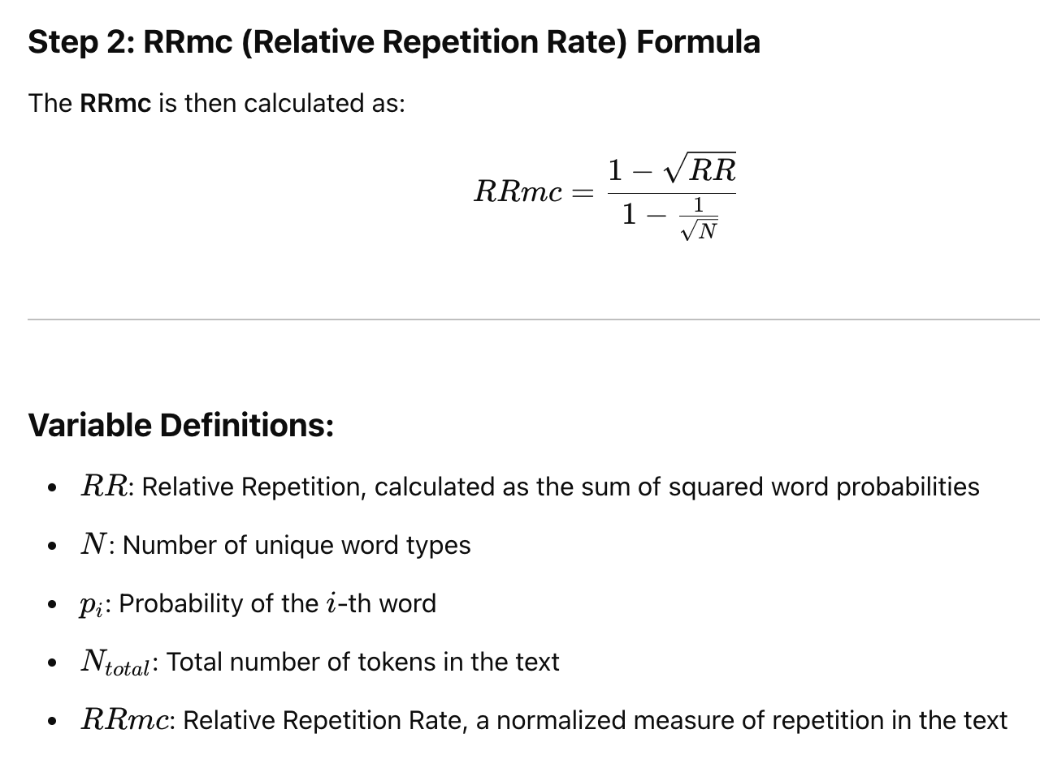

## HLP (Hapax Legomena Proportion)

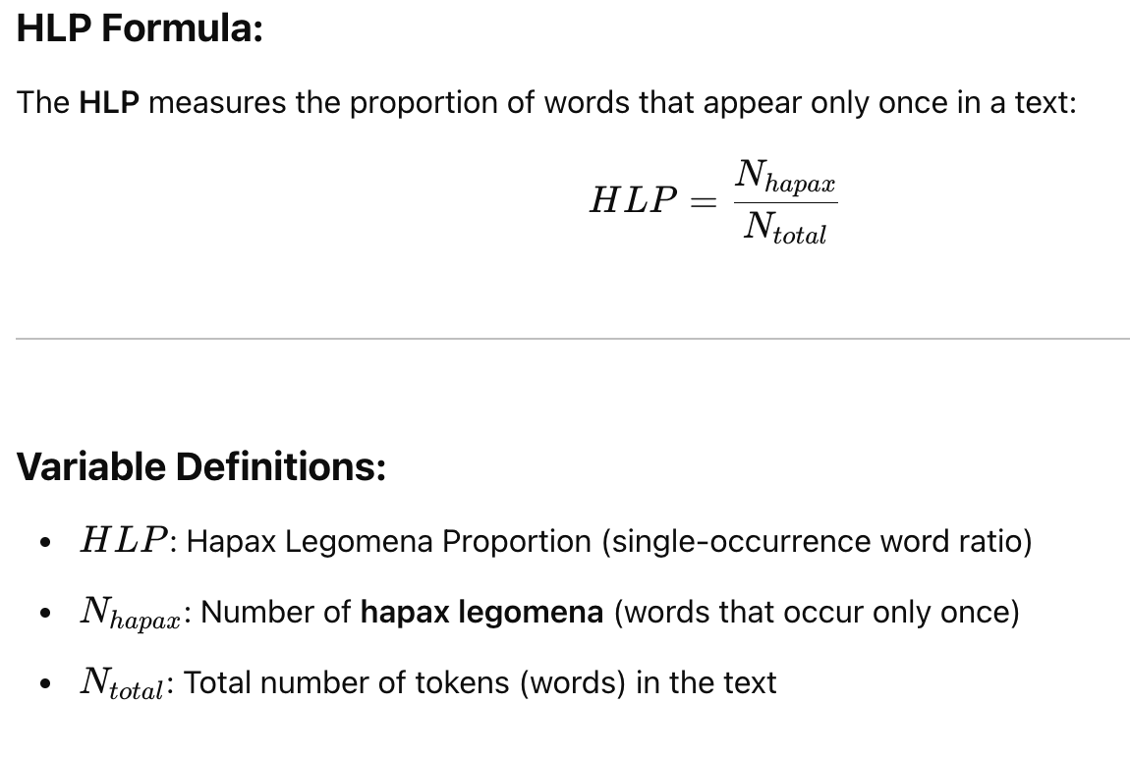

2.3.1平均依存距离 mean dependence distance (MDD)

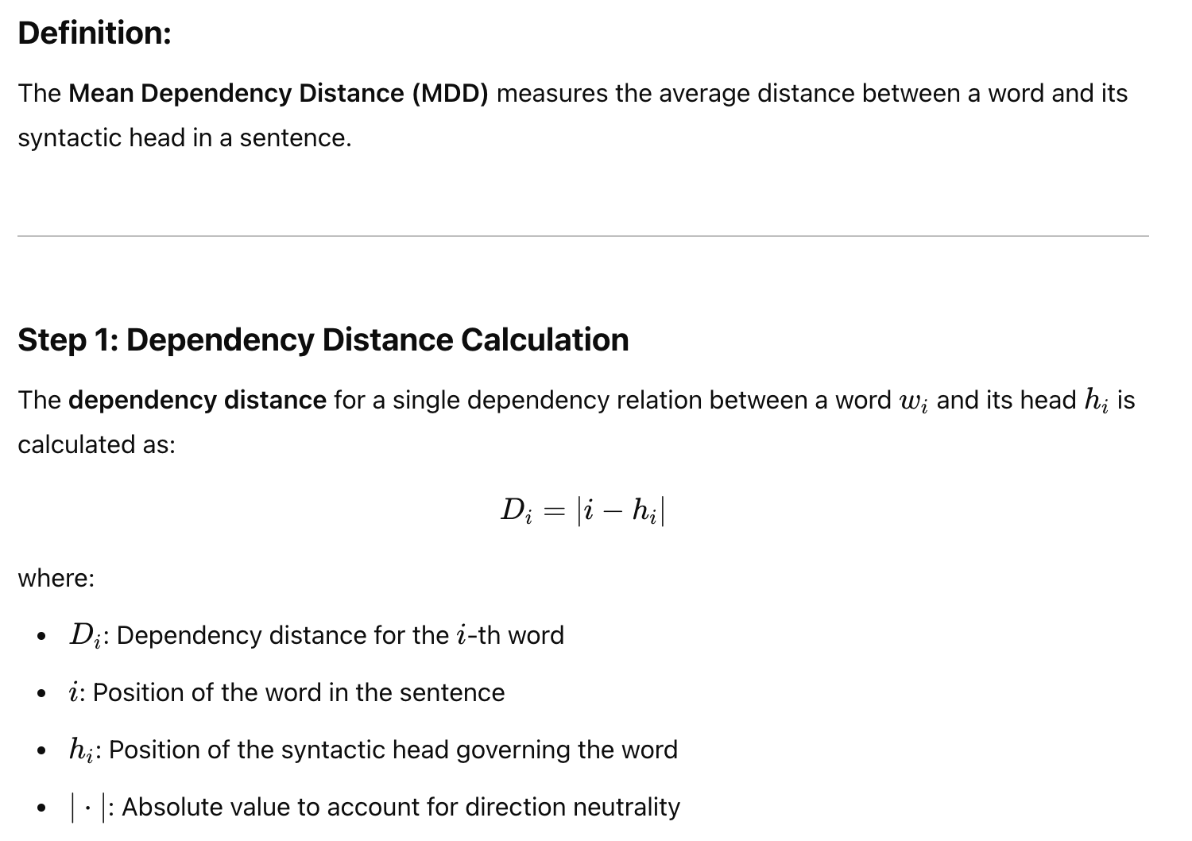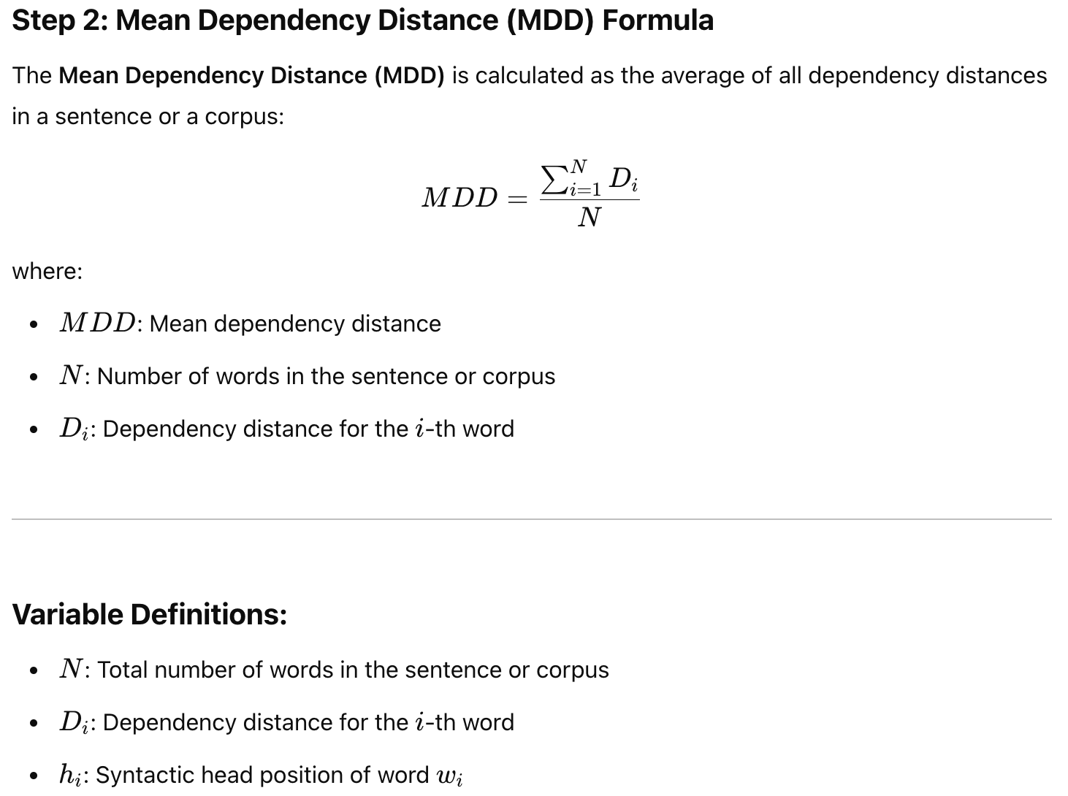

2.3.2依存关系多样性 MSTTRDR

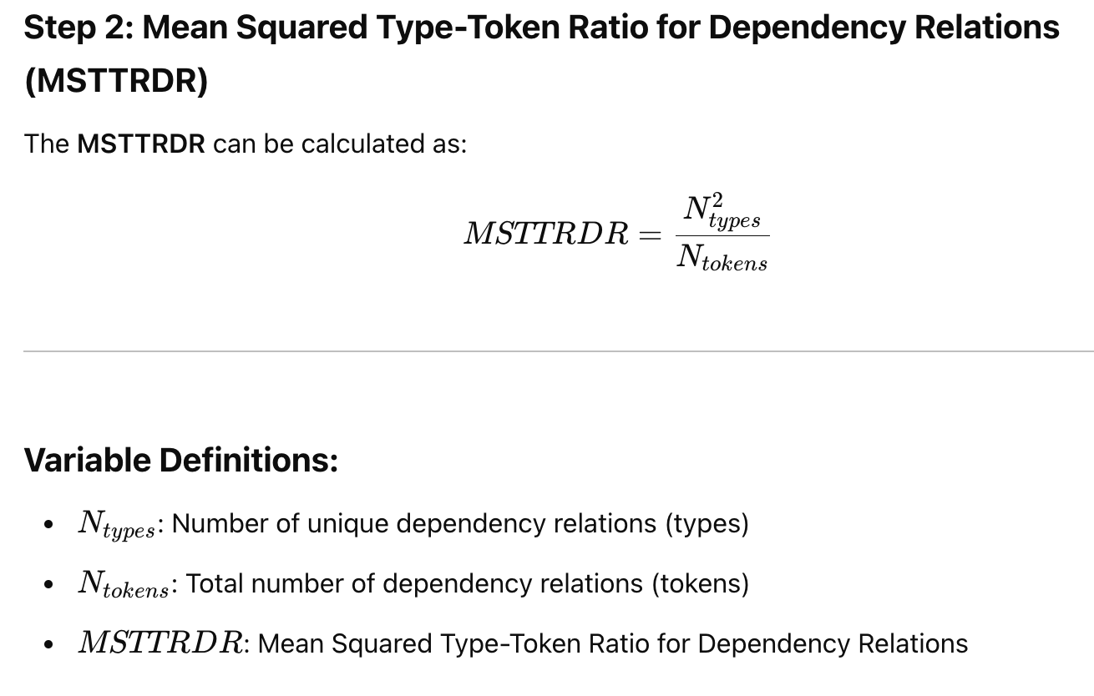

2.3.3依存关系类型比例 DRTR

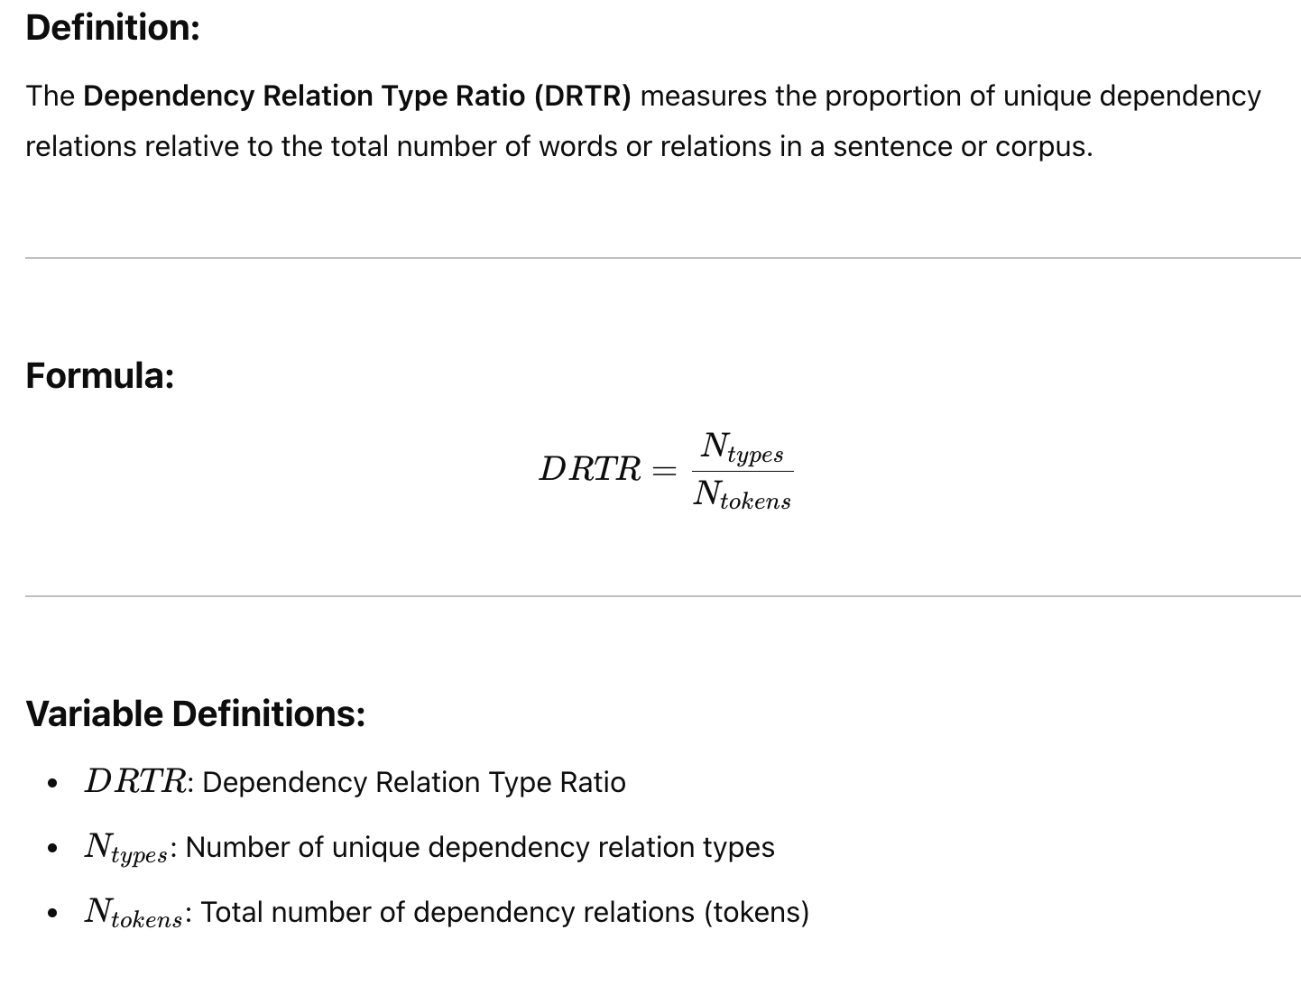

2.3.4名词主语占比

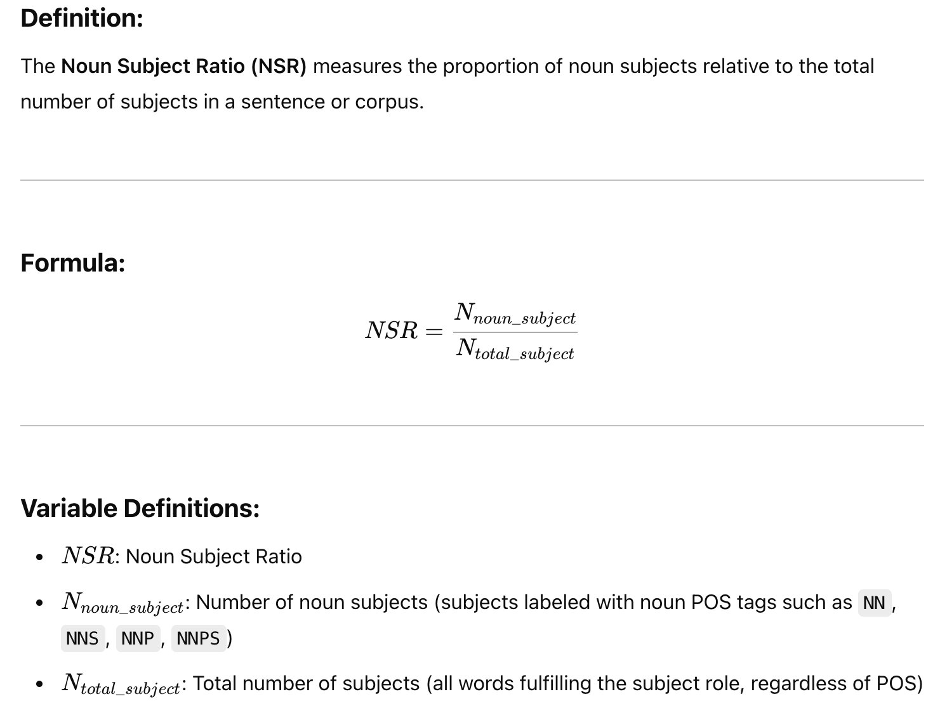

2.4 情感分析比例（基于NRC情感词典）

(NRC: <https://saifmohammad.com/WebPages/NRC-Emotion-Lexicon.htm）>

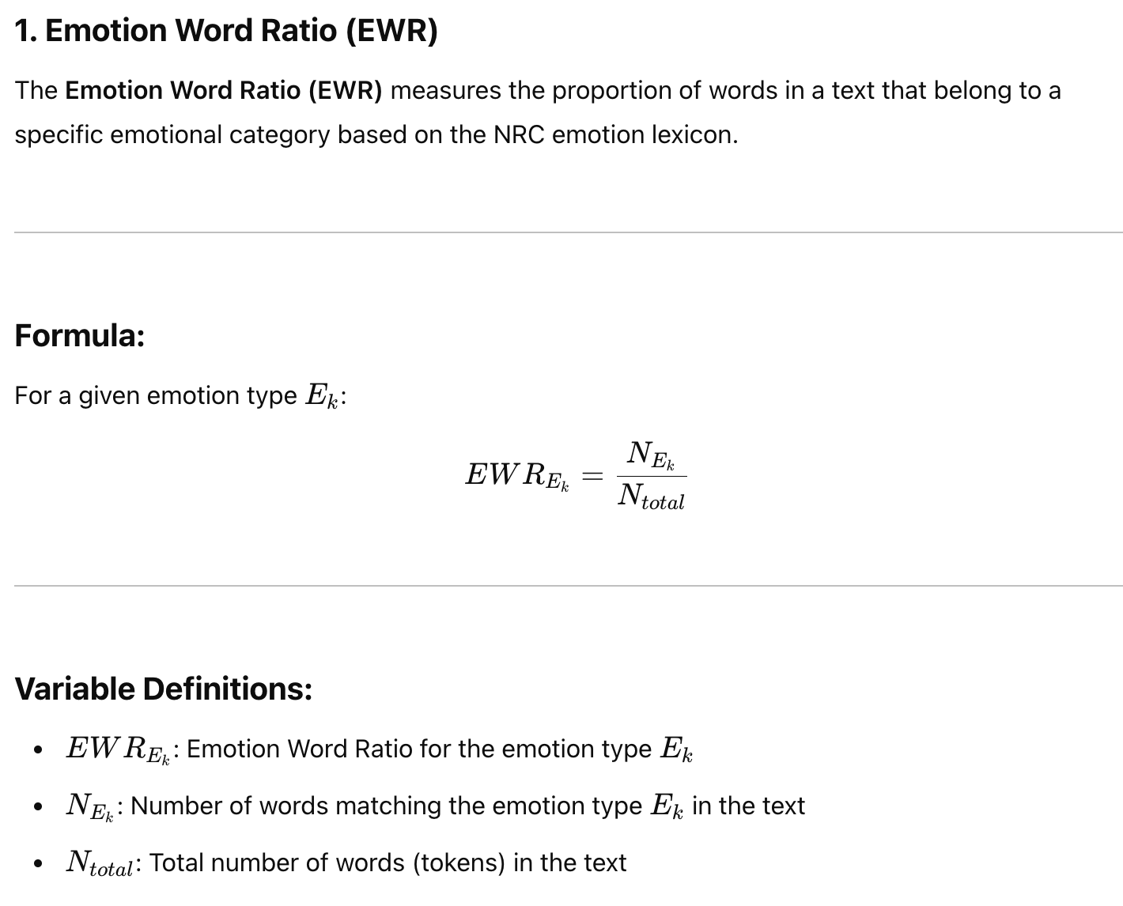

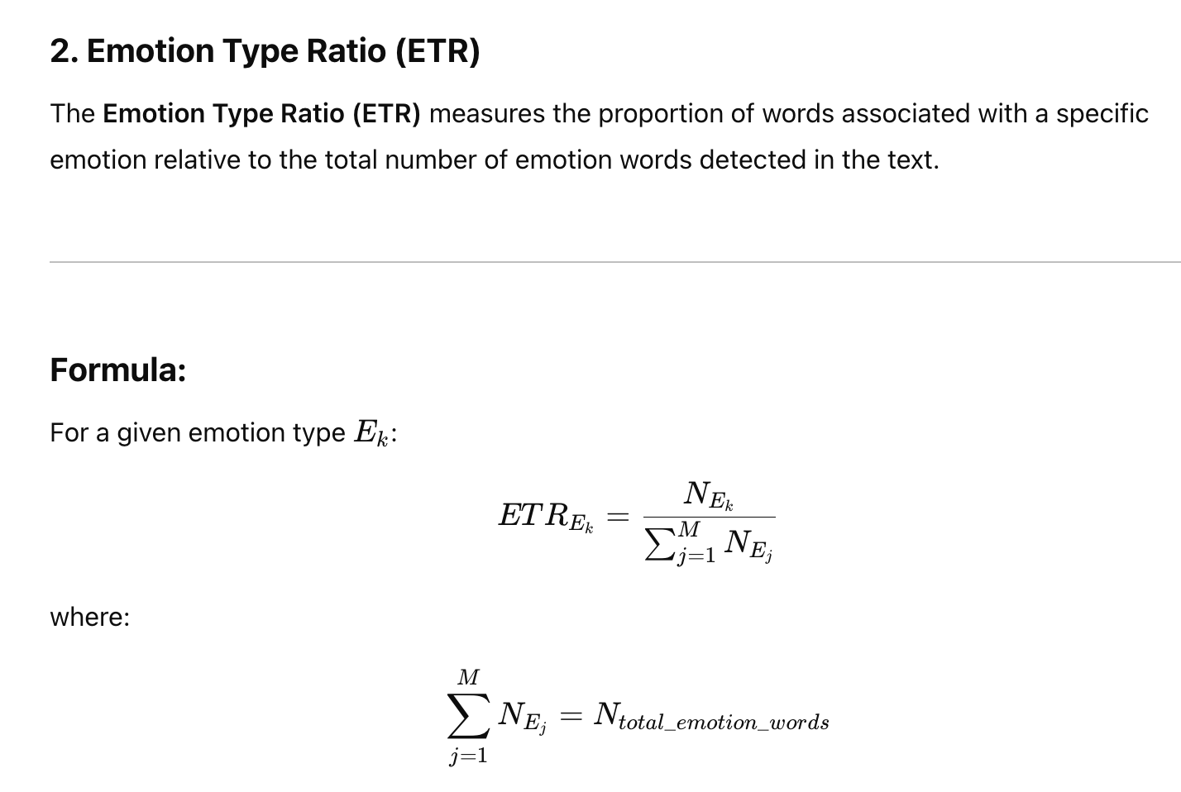

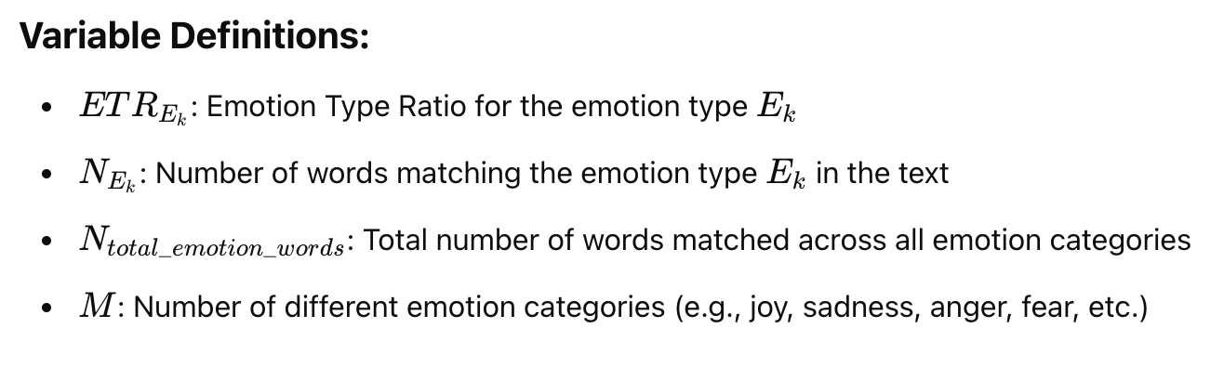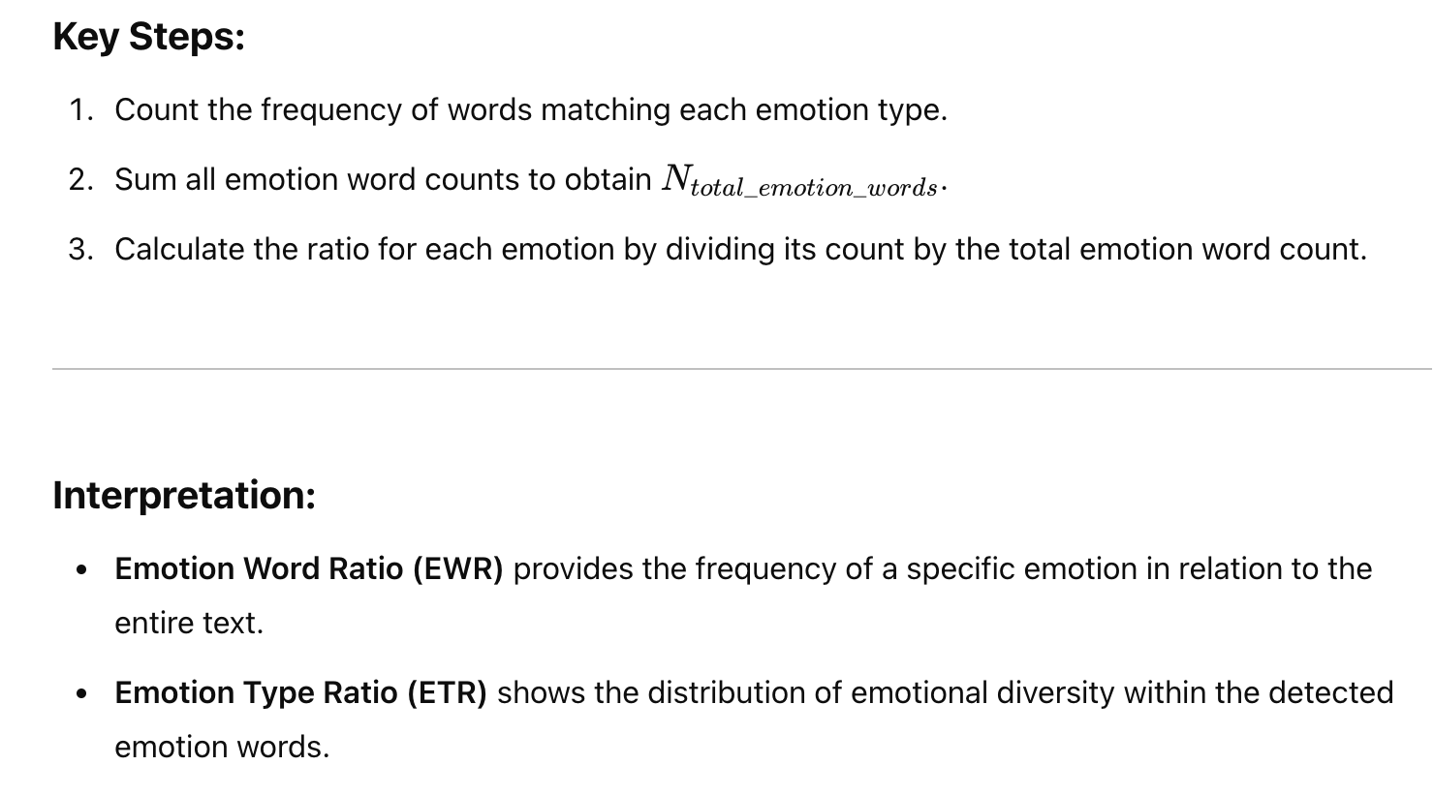

2.5文本可读性

2.5.1 弗莱士-金凯德难度级数（Flesch-Kincaid Grade Level，FKGL）

2.5.2弗莱士易读度 （Flesch Reading Ease，FRE）

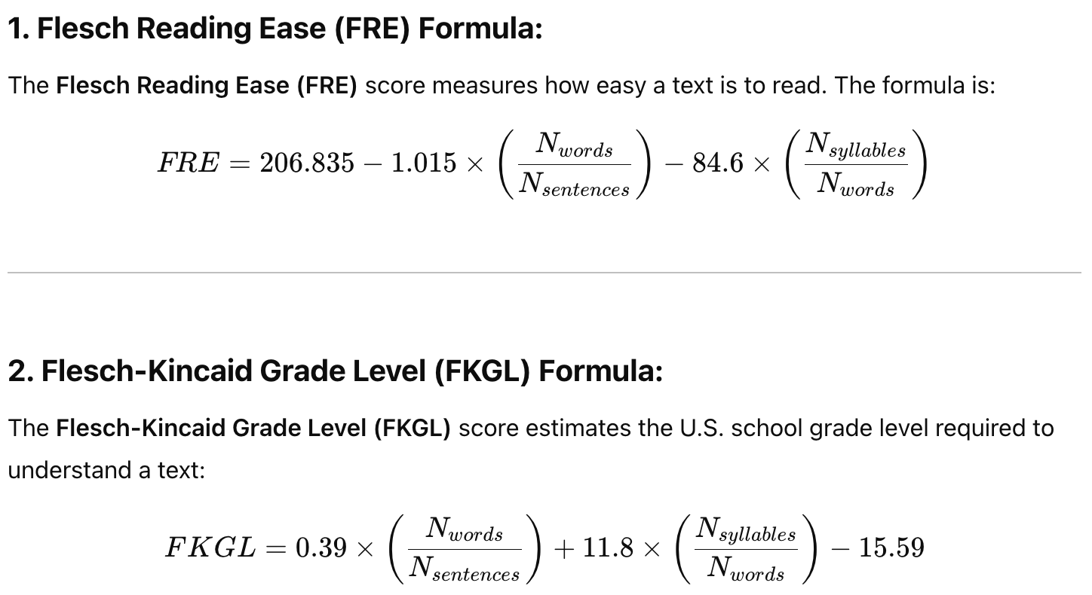

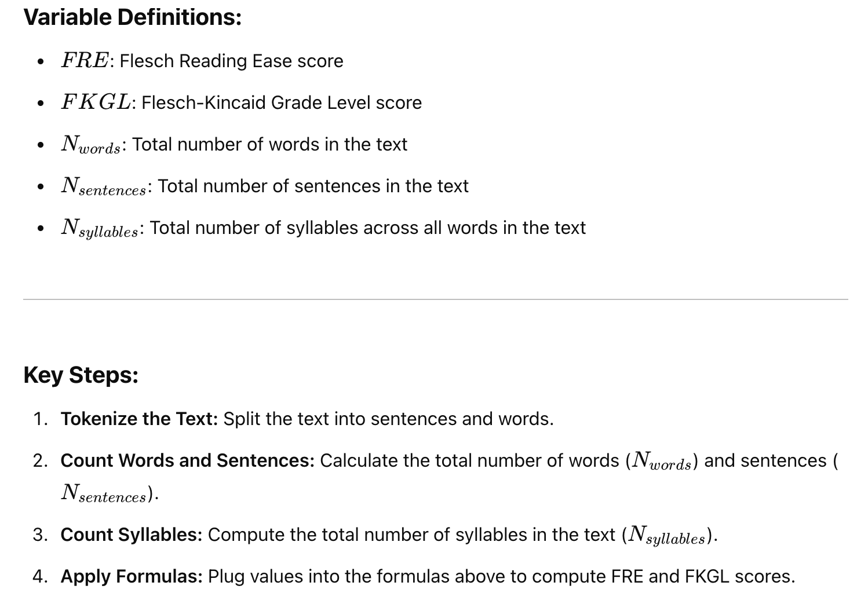

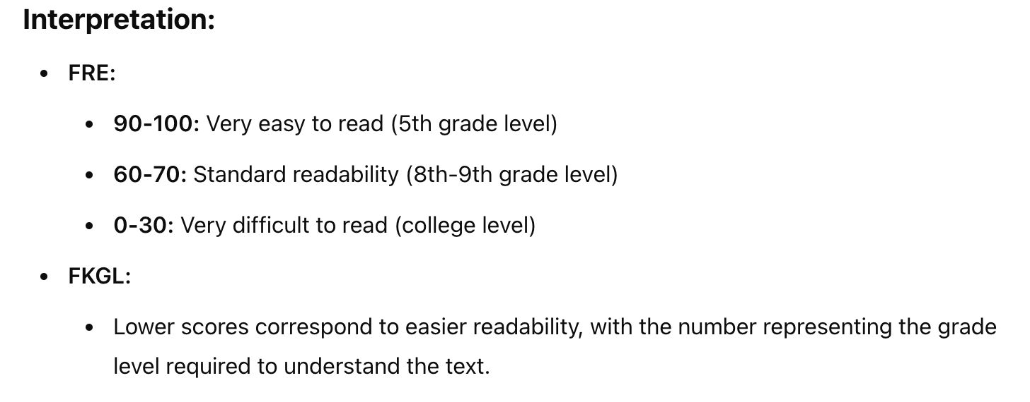

2.5.3 柯派氏指数（Coleman-Liau Index，CLI）

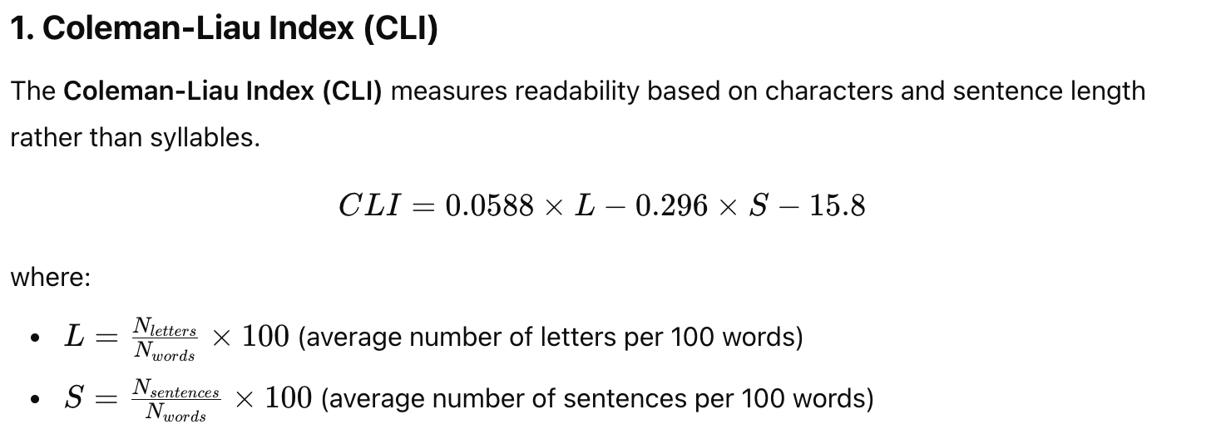

2.5.4 SMOG指数（Simplified Measure of Gobbledygook，SMOG）

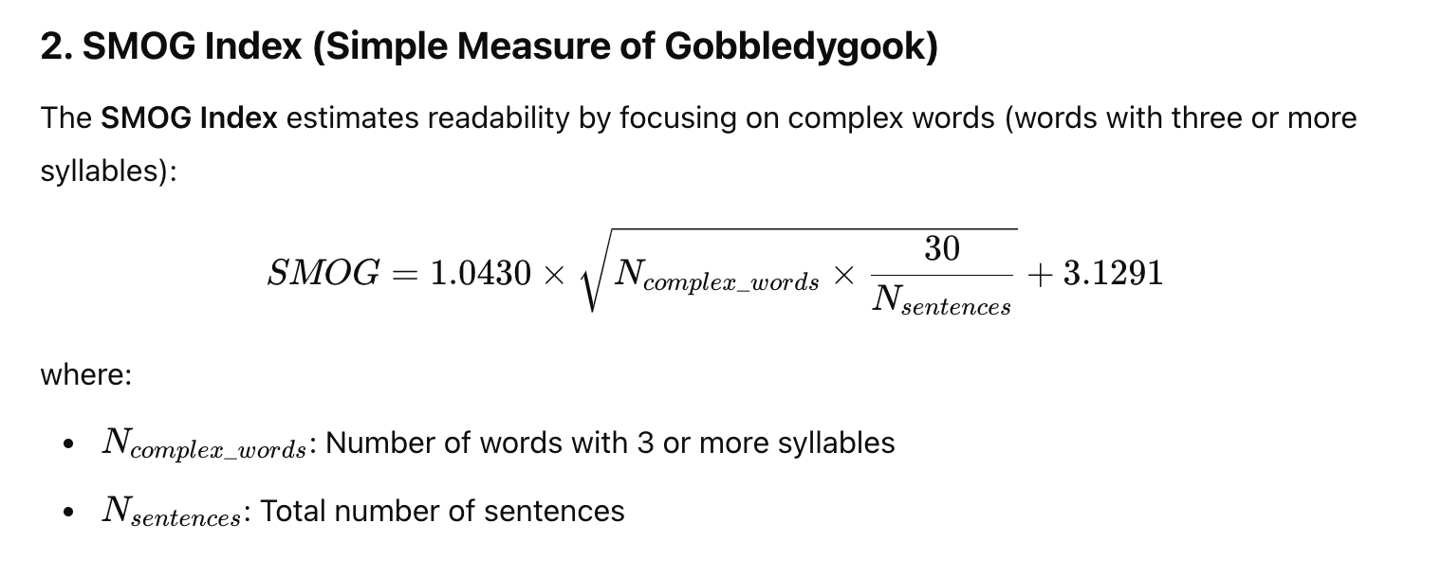

2.5.5 自动可读性指数（Automated Readability Index，ARI）

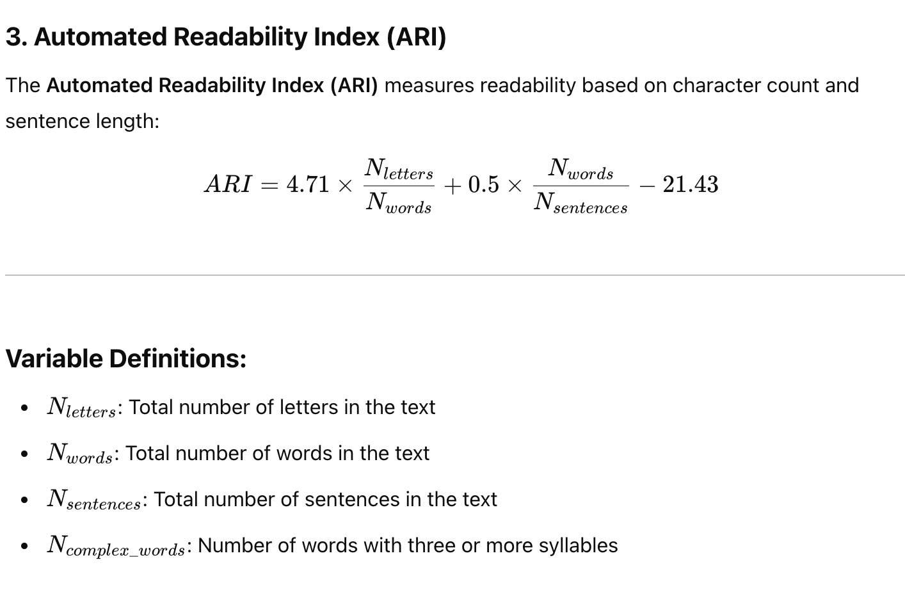

2.5.6 LIX指数

